**Rates of Reaction – Factors Affecting Rate**

Chemical reactions occur because reactant particles collide with each other with enough energy to react. This is called the *activation energy*.



When particles collide with at least the activation energy we call these *successful collisions*. Increasing the frequency of successful collisions increases the rate of reaction.



The rate of a chemical reaction can be described as

Change in concentration, volume or mass

Time

If we change one of the conditions in the reaction, the rate will also change

**Temperature**

Increasing temperature increases the rate of reaction because

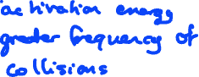

**Concentration (liquids) and pressure (gases)**

Increasing concentration or pressure increases the rate of reaction because



**Surface area**

Increasing the surface area of the reactants increases the rate of reaction because



**Catalysts**



Adding a catalyst increases the rate of reaction because

