Measuring Rates – Continuous Method
This method involves measuring how the concentration of a reactant or product changes over time. Samples of the reaction mixture are taken at regular intervals and the reaction is quenched.
We plot a graph of concentration over time. The gradient of the curve at a specific point is the rate at that time. We can also tell the order of reaction based on the shape of the graph.
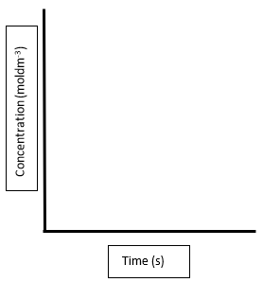

Concentration (moldm⁻³)

Time (s)

Focus – First Order reactions

Constant half life

Calculating k

