**Group 7**

Fluorine Chlorine



Bromine Iodine



Astatine



**Reactivity**

The halogens are less reactive as you go down the group. They all gain an outer electron when they react. As you go down the group, they are less likely to gain an electron because

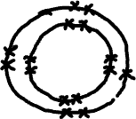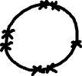

F Cl

* The incoming electron is farther from the nucleus
* There are more shells between the nucleus and incoming electron (shielding)
* Together, these mean the attraction between the incoming electron and the nucleus is weaker

**Displacement**

Displacement reactions can prove the trend in reactivity.

*A more reactive halogen will displace a less reactive halogen from its compounds*



chlorine + sodium bromide 🡪 sodium chloride + bromine



Cl2 + 2NaBr 🡪 2NaCl + Br2



*Ionic Cl2 + 2Br- 🡪 2Cl- + Br2*



iodine + sodium bromide 🡪 ???



(Note – Bromine solution is _______________ and iodine solution is _________)

