**Gases in the Atmosphere**

There are 4 main gases in the atmosphere.

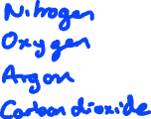

**Determining % oxygen in the air**

When a substance burns in air it is reacting with the oxygen. If we measure how much air we had before the burning/reaction and measure how much air is left at the end of the reaction we can calculate how much oxygen was used up. We can therefore calculate the % oxygen in the air using the equation





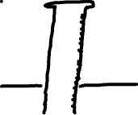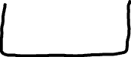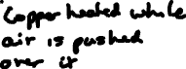

E.g. 1 E.g. 2

|  |  |
| --- | --- |
| Volume air at start cm3 |  |
| Volume air at end cm3 |  |

|  |  |
| --- | --- |
| Volume air at start cm3 |  |
| Volume air at end cm3 |  |



**Combustion**

When elements burn in oxygen it is called combustion. For example -magnesium, sulfur and hydrogen



**Thermal decomposition**

This is breaking down a substance using heat. When metal carbonates are heated, they decompose into the metal oxide and carbon dioxide.

E.g. copper carbonate



**Carbon dioxide**

CO2 is a ____________________ gas. This means it prevents reflected heat from the sun from escaping the Earth’s atmosphere. This is necessary for life to survive, however, current CO2 levels are very high and this is thought to be a major contributor to global warming.

