**Elements, Compounds and Mixtures**

**Definitions**

Element – Contains only 1 type of atom

Compound – 2 or more elements chemically combined

Mixture – 2 or more substances mixed together that can often be easily separated

**Pure or impure**

Elements and compounds are pure substances. They will melt and boil at specific temperatures. A mixture will melt and boil over a range of temperatures.



**Separating mixtures**

1 – Simple distillation



2 – Fractional distillation



3 – Filtration



4 – Crystallisation



5 – Chromatography



**Chromatography**

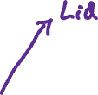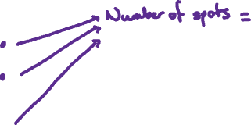

**Rf Values**

We can identify substances in a mixture using Rf values. Rf values show how far a substance travels in a chromatogram



4.7

6.2

A B X