Measuring Rates – Initial Method
This method involves repeating an experiment using different concentrations of reactant and measuring the initial rate.
E.g. the iodine clock. If iodine is a product of the reaction starch indicator will turn blue-black. However, this will happen instantly regardless of the concentration of reactants we use. We can add a small amount of sodium thiosulfate to mask the initial part of the reaction. Once the thiosulfate is used up, iodine is produced and the colour change is seen.
We plot a graph of rate over concentration. We can tell the order of reaction based on the shape of the graph.
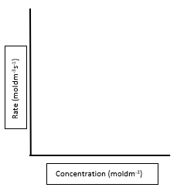

Rate (moldm⁻³s⁻¹)

Concentration (moldm⁻³)

Focus – First Order reactions

Calculating k

