**Constructing Born-Haber Cycles**

Born Haber Cycles are similar to Hess Cycles in that they show us 2 possible routes for a reaction. They are designed to allow us to calculate Lattice energy.

Consider the lattice energy for NaCl

Na+(g) + Cl-(g) 🡪 NaCl(s)

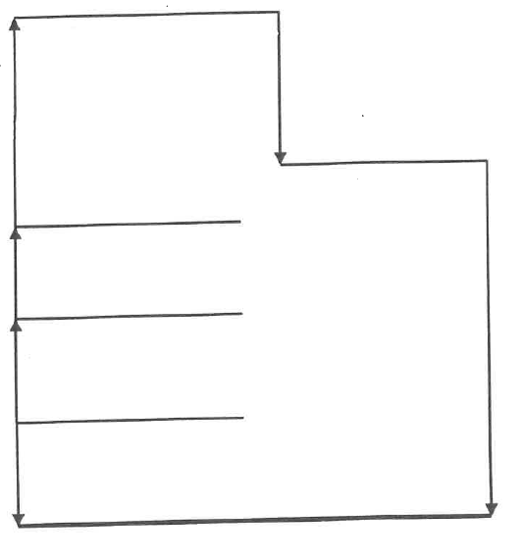In order to complete this reaction we must first turn sodium and chlorine into their ions.



Enthalpy



E.g. Calcium oxide

|  |  |  |
| --- | --- | --- |
| Enthalpy Change | Value kJ mol-1 | Equation |
| ∆fH [CaO(s)] | -635 |  |
| ∆atH [Ca(s)] | +193 |  |
| ∆atH [½O2(g)] | +248 |  |
| I.E.1 [Ca(g)] | +590 |  |
| I.E.2 [Ca(g)] | +1150 |  |
| E.A.1 [O(g)] | -142 |  |
| E.A.2 [O(g)] | +844 |  |

