**Energetics – energy level diagrams**

We can show the energy changes in a reaction on energy level diagrams.

C2H5OH(l) + 3O2(g)  🡪 2CO2(g) + 3H2O(l) ∆H = -1366.8 kJ/mol



NH4Cl(s) + H2O(l) 🡪 NH4Cl(aq) ∆H = +13.8 kJ/mol



**Reaction Profile Diagrams**

These are similar to energy level diagrams but also show the activation energy for the reaction

C2H5OH(l) + 3O2(g)  🡪 2CO2(g) + 3H2O(l) ∆H = -1366.8 kJ/mol

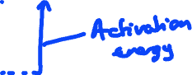

NH4Cl(s) + H2O(l) 🡪 NH4Cl(aq) ∆H = +13.8 kJ/mol

